PRESS RELEASE

High Dynamic Range 12-bit 4 GSPS Dual Channel PCIe Data Acquisition Board Streams to Host at 6.5-7 GB/s

Berkeley, CA, September 14, 2017 – FOR IMMEDIATE RELEASE
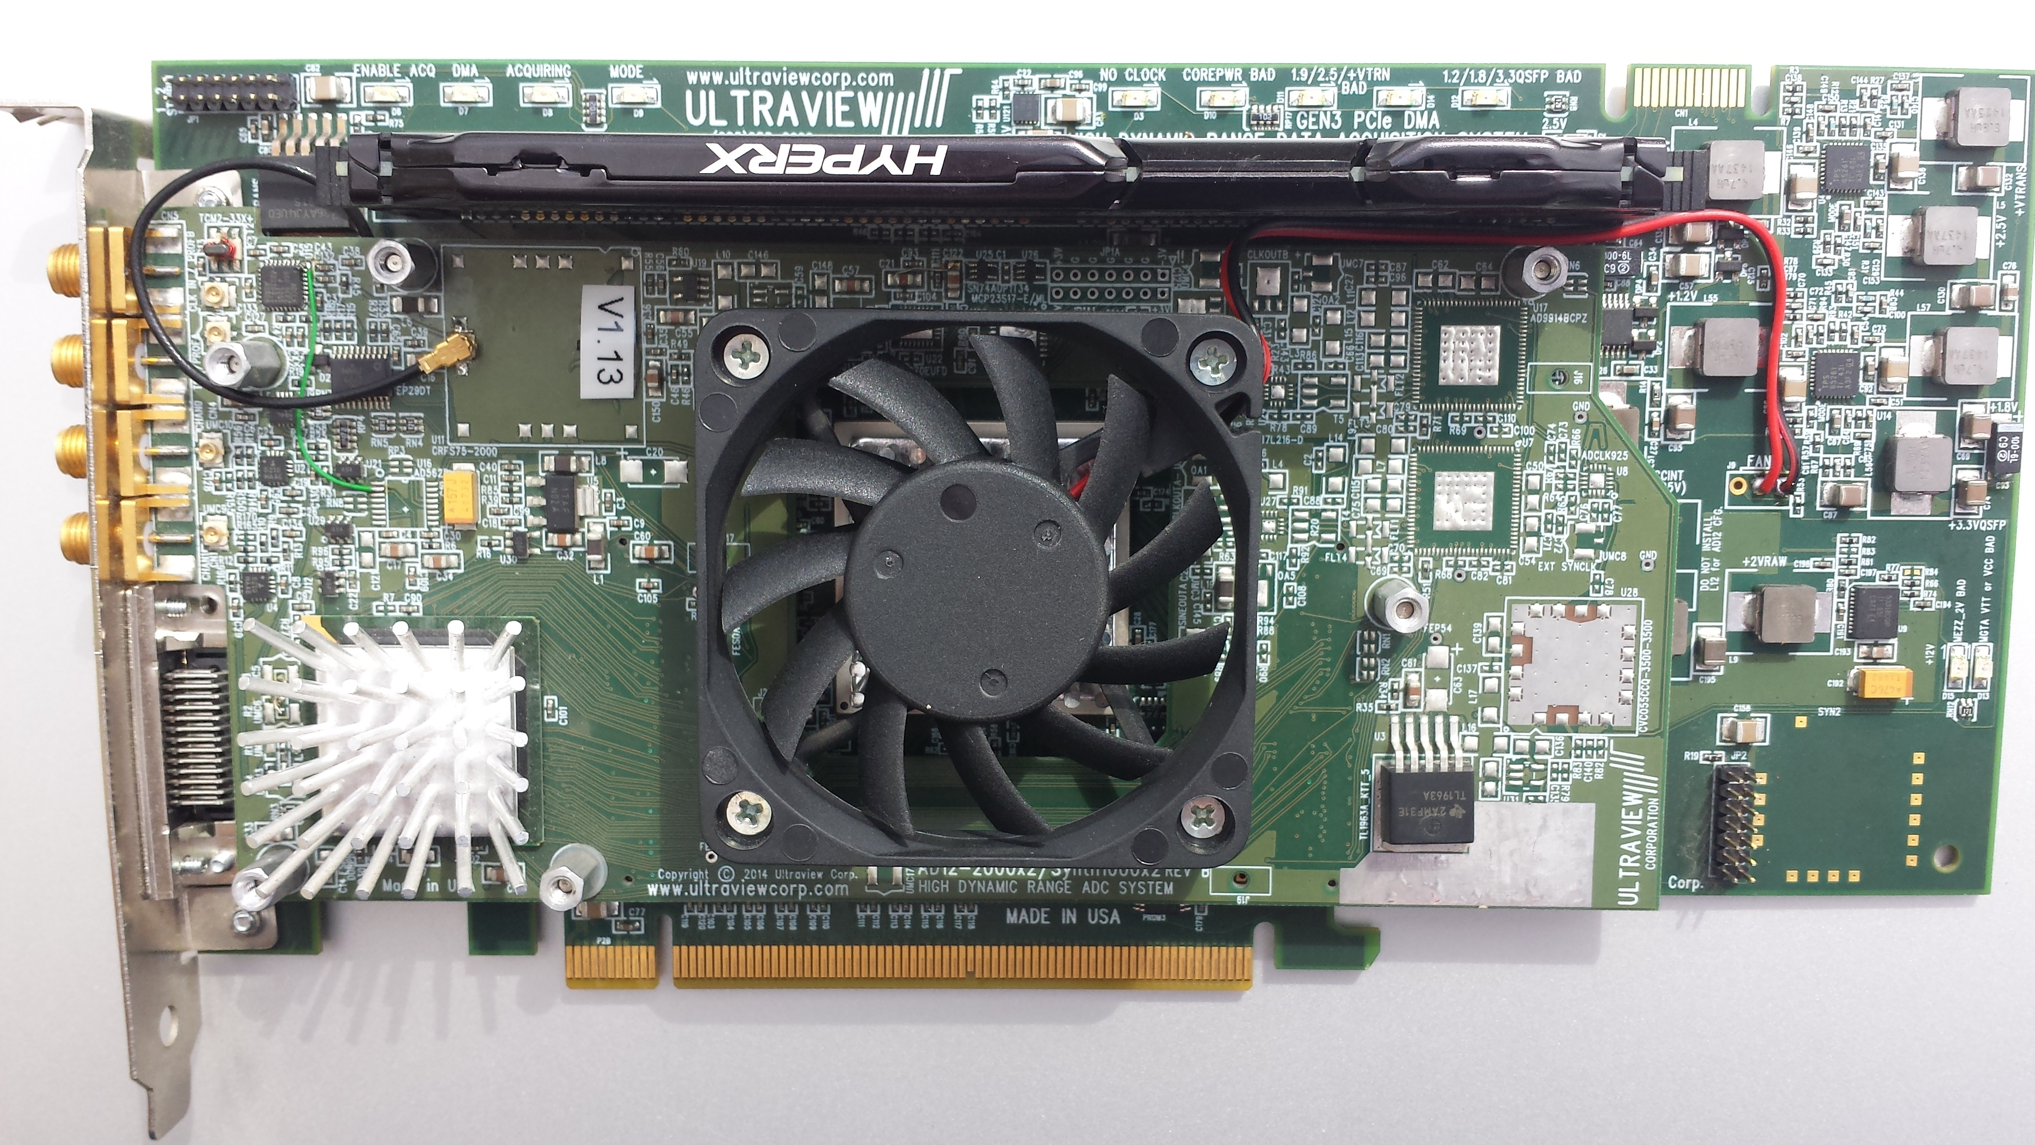

DAQ with zero-dead-time waveform averaging and triggering for baseband or direct-IF sampling in SIGINT, radar, scientific & Imaging apps.

Ultraview Corporation has announced an ultra-fast 4GSPS dual-channel 12-bit PCIe Gen3 data acquisition board allowing concurrent acquisition of two 12-bit A/D channels at up to 2 GSPS (4 GSPS for 1-channel). The AD12-2000x2K7US’s unique combination of a low-noise DC-2 GHz front end, fast ECL, TTL and analog waveform triggers, deep 8GB on-board buffer, and programmable sampling rate from either a low-jitter internal synthesizer or an external clock enable new capabilities in communications, spectroscopy, SIGINT, surveillance, missile testing, radar and other defense, scientific, and medical applications. When installed in any x16 or x8 PCIe slot, the AD12-2000x2K7US can acquire data at up to 8 GB/sec, optionally process it in the on-board Kintex7Ultrascale FPGA, and continuously stream the data via 6.5-7GB/sec (system dependent) DMA to host system RAM for immediate use, display, or storage to disk. When installed in a suitable system with dedicated RAID, optional data recorder software enables seamless recording of terabytes of data without interruption.

Low Latency Rapidly-Retriggerable Acquisition and Zero-Dead-Time Hardware Averaging allows -150dB Displayed Average Noise Level (DANL)

ECL/PECL/edge trigger inputs cause sampling to start within 40ns of trigger, and a selective recording feature allows acquisition to then be dynamically stopped and started in response to a TTL input, reducing memory or disk usage and bandwidth by storing only needed data, for RADAR, NMR and burst communication applications. The board can automatically acquire specified burst lengths of data ranging from 4 Gigasamples down to only a few kilosamples, repeatably triggered, with only a few samples dead time between bursts. Alternatively a scope-like adjustable waveform trigger can be used to acquire, and optionally average, thousands of waveform segments, enabling a DANL of -150dB.

TTL Inputs concurrent with sampling, for Precise Time Correlation of Analog and Digital Events

The board can sample up to 4 TTL signals concurrently with the analog inputs, for time-locked registration of the analog data with fiducials such as radar antenna angle, sweep retrace, etc.

Low-jitter internal synthesizer for software programmable data acquisition rate, as well as
Wide-range External Clock for Swept measurements
The AD12-2000x2K7US supports external clocks of 300 MHz to 2000 MHz (600 MSPS to 4000 MSPS on a single channel). It also has a low-jitter programmable internal clock.

Rapid Development and OEM-customization using easily modifiable, Linux/Windows cross-platform C-Software/VHDL-Firmware packages included with board

Designed for critical applications, the AD12-2000x2K7US allows either straight DAQ, requiring no user development, or in-line FPGA dataflow processing using the on-board Xilinx Kintex7 Ultrascale FPGA.

For use as a standard data acquisition board the supplied software allows users to acquire, view, and store, data “right out of the box”. Drivers, user software and example source code are supplied for both 64-bit Linux and 64bit Windows10TM and 7. Graphical waveform display software, and routines to store data to disk are included with all boards, in C-language source and ready-to-run executable form. A complete, high visibility, LabVIEWTM control panel display for 64-bit Windows is also included.

An optional GUI-based “Data Recorder” package allows data to be stored at over 6GB/s into system RAM or RAID. Preconfigured rack-mountable, multi-terabyte, data recorder systems containing AD12-2000x2K7US boards may also be purchased.

The AD12-2000x2K7US shares a modular Front-end Mezzanine architecture with Ultraview’s complete line of 8, 12, 14 and 16-bit A/D boards, enabling a common software platform for all models. .

Rapid Customization, Library of Firmware IP Cores

The AD12-2000x2K7US's supplied VHDL firmware source lets users optionally modify the board's supplied standard data acquisition firmware to perform advanced application-specific hardware signal processing, including filtering, sub-band tuning, spectroscopy, SDR, ultra-fast real-time tone decoding, and image processing. This modular VHDL firmware source is available to OEM users at no charge under NDA. The company also offers custom firmware development for OEM applications.

Low Total System pricing. Standard PCIe x16 format allows installation in low-cost systems

Pricing in quantity of 1-4 boards is $15,995 for AD12-2000x2-8GB-K7US. Availability: Stock.

About Ultraview Corporation

Ultraview, founded in 1987, manufactures a wide range of OEM and COTS 8, 12, 14 and 16-bit PCI/PCIe data acquisition boards, PCI/PCIe bus live insertion extender boards and analysis tools. These products are used in a wide variety of applications in defense, communications, scientific, medicine, education and research.

Press and Sales Contact

Barbara Sacks
Ultraview Corporation
808Gilman St., Berkeley, CA., 94710
bsacks@ultraviewcorp.com
925.253.2960 Office
925.253.4894 Fax
www.ultraviewcorp.com
PRESS PACKAGE available at: http://www.ultraviewcorp.com/ad12-2000/pr
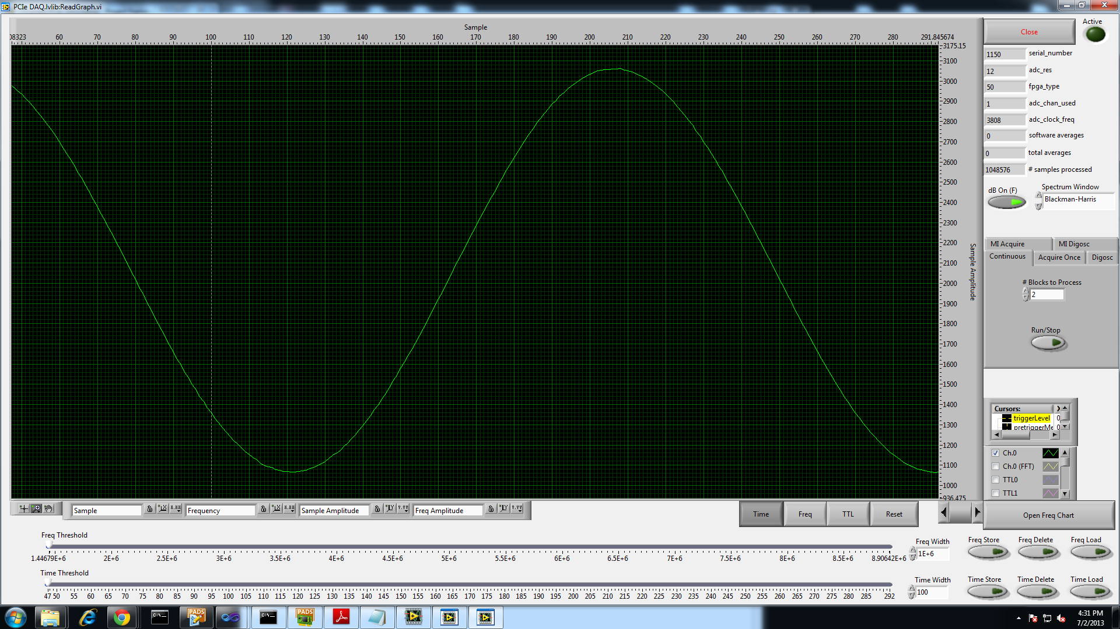
Quietest (Highest SNR) 4GSPS / Dual2GSPS 12-bit A/D on the market

